CSE 581

**Lab 4: More Advanced Selects**

*Do this lab against the Northwind database.*

***For the entire lab, provide all of your SQL as text, inserted at the beginning of the document.***

***For each step also provide a screenshot of execution, showing the SQL and the results.***

***Please make sure both the SQL and the screenshots are marked w/ the question number that they are answering.***

**Steps:**

1. List all company names and number of orders they placed, for companies that placed 5 or more orders.

SELECT CompanyName, count(*) as numberoforders

FROM Customers c left outer join orders o

on c.customerid=o.customerid

group by Companyname

having count(*) >= 5;

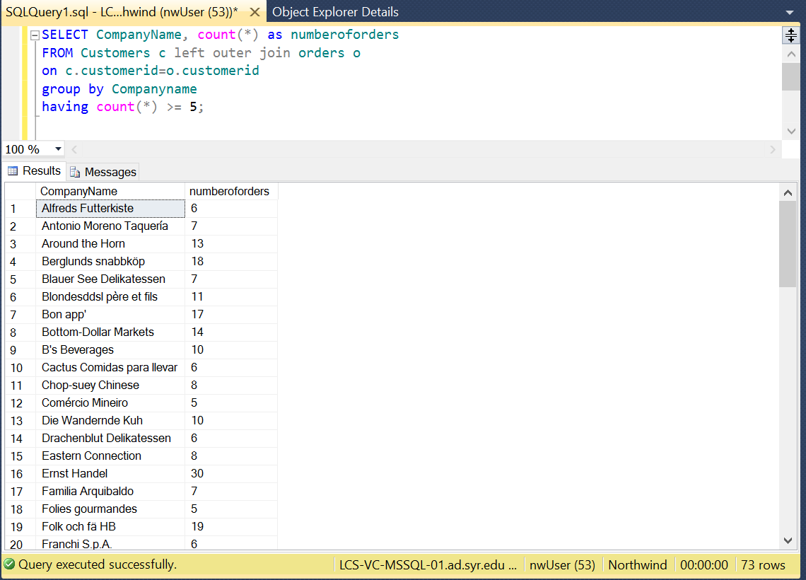

1. List all employees (names and IDs only) and their corresponding managers (names only).

SELECT CONCAT(E.FIRSTNAME,' ',E.LASTNAME)AS EMPLOYEENAME, E.EMPLOYEEID, CONCAT(R.FIRSTNAME,' ',R.LASTNAME) AS MANAGER

FROM EMPLOYEES E left outer join EMPLOYEES R

on R.EMPLOYEEID=E.REPORTSTO;

